Company Database Schema

Here is the schema of a company database, please implement it on any RDBMS you like and then try to create the following requests (queries): "create only the dependent table with all data and relations"

Employee:
Fname | Lname | SSN | BDATE | Addresss | Gender | Salary | Superssn | Dno
Ahmed | Ali | 112233 | 1/1/1965 | 15 Ali fahmy St.Giza | M | 1300 | 223344 | 10
Kamel | Mohamed | 223344 | 15/10/1970 | 38 Mohy el dien abo el Ezz St.Cairo | M | 1800 | 321654 | 10
Hanaa | Sobhy | 123456 | 18/3/1973 | 38 Abdel Khalik Tharwat St. Downtown.Cairo | F | 800 | 223344 | 10
Amr | Omran | 321654 | 14/9/1963 | 44 Hilopolis.Cairo | M | 2500 | null | null
Noha | Mohamed | 968574 | 1/2/1975 | 55 Orabi St. El Mohandiseen .Cairo | F | 1600 | 321654 | 20
Edward | Hanna | 512463 | 19/8/1972 | 18 Abaas El 3akaad St. Nasr City.Cairo | M | 1500 | 321654 | 30
Mariam | Adel | 669955 | 12/6/1982 | 269 El-Haram st. Giza | F | 750 | 512463 | 20
Maged | Raoof | 521634 | 6/4/1980 | 18 Kholosi st.Shobra.Cairo | M | 1000 | 968574 | 30

Department
Dname | DNum | MGRSSN | MGRStart Date
DP1 | 10 | 223344 | 1/1/2005
DP2 | 20 | 968574 | 1/3/2006
DP3 | 30 | 512463 | 1/6/2006

Works_on
ESSN | Pno | WeeklyHours
223344 | 100 | 10
223344 | 200 | 10
223344 | 300 | 10
112233 | 100 | 40
968574 | 400 | 15
968574 | 700 | 15
968574 | 300 | 10
669955 | 400 | 20
223344 | 500 | 10
669955 | 700 | 7
669955 | 300 | 10
512463 | 500 | 10
512463 | 600 | 25
521634 | 500 | 10
521634 | 600 | 20
521634 | 300 | 6
521634 | 400 | 4

Project
Pname | Pnumber | Plocation | City | Dnum
AL Solimaniah | 100 | Cairo_Alex Road | Alex | 10
Al Rabwah | 200 | 6th of October City | Giza | 10
Al Rawdah | 300 | Zaied City | Giza | 10
Al Rowad | 400 | Cairo_Faiyom Road | Giza | 20
Al Rehab | 500 | Nasr City | Cairo | 30
Pitcho american | 600 | Maady | Cairo | 30
Ebad El Rahman | 700 | Ring Road | Cairo | 20

Dependent
ESSN | Dependent_name | Gender | Bdate
112233 | Hala Saied Ali | F | 18/10/1970
223344 | Ahmed Kamel Mohamed | M | 27/3/1998
223344 | Mona Adel Mohamed | F | 25/4/1975
321654 | Ramy Amr Omran | M | 26/1/1990
321654 | Omar Amr Omran | M | 30/3/1993
321654 | Sanaa Gawish | F | 16/5/1973
512463 | Sara Edward | F | 15/9/2001
512463 | Nora Ghaly | F | 22/6/1976

Data Manipulating Language:

- Insert your personal data to the employee table as a new employee in department number 30, SSN = 102672, Superssn = 112233.

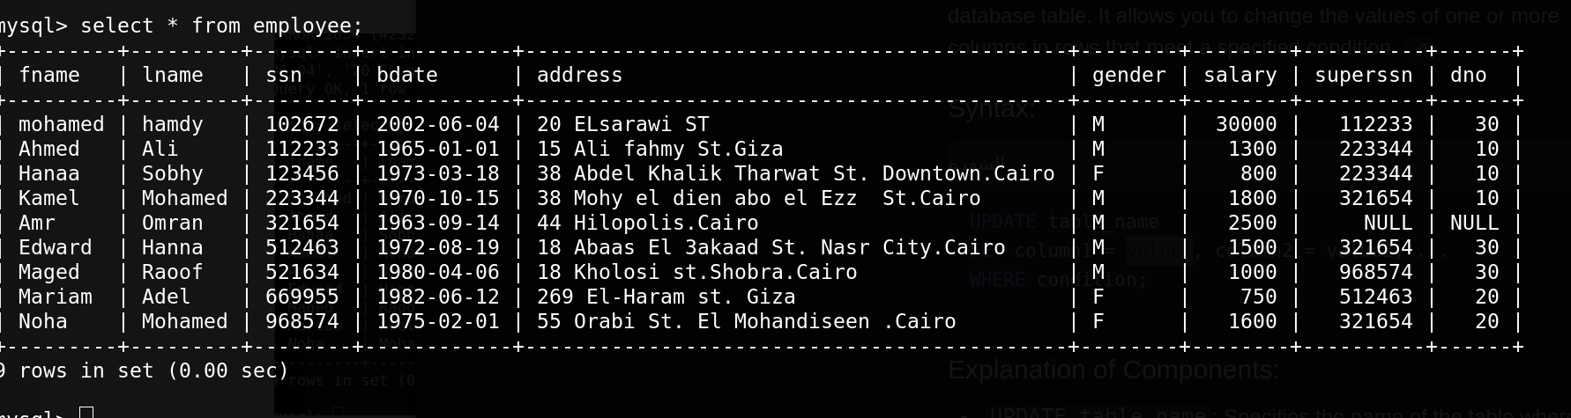

- Insert another employee with personal data your friend as new employee in department number 30, SSN = 102660, but don’t enter any value for salary or manager number to him.

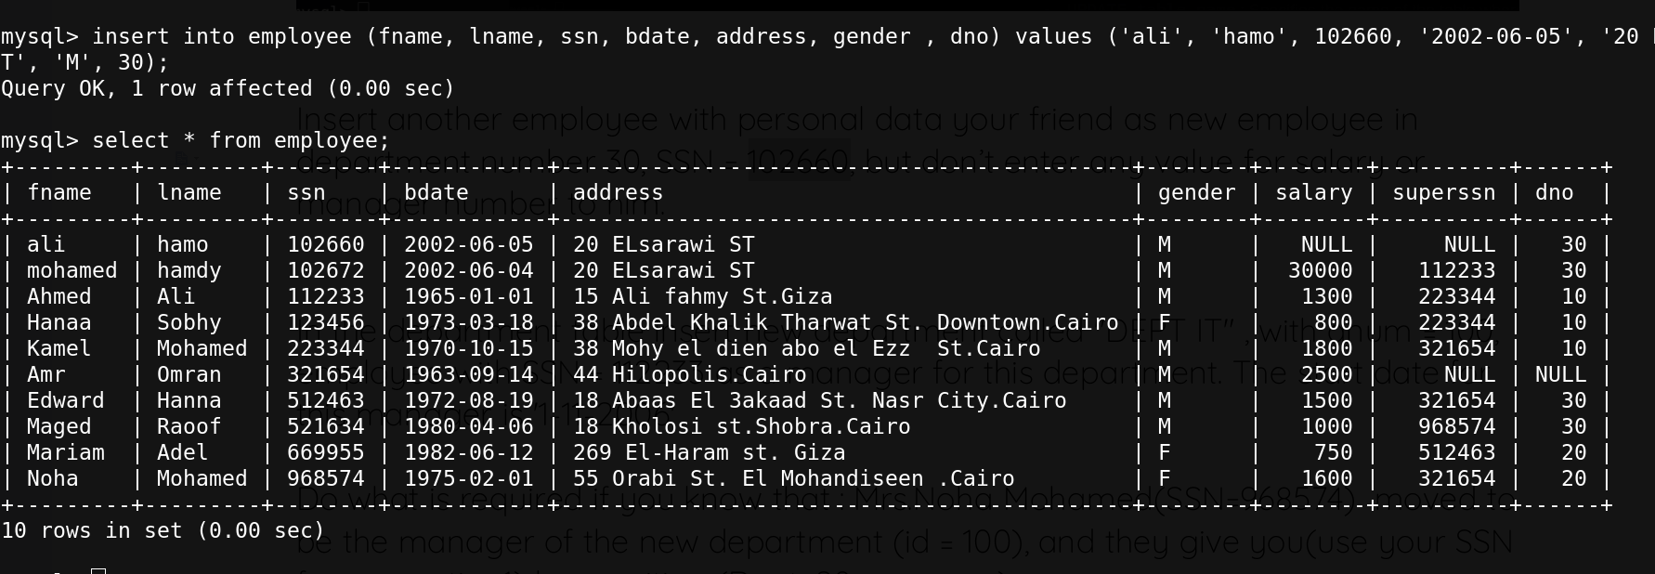

- In the department table insert new department called "DEPT IT" , with dnum = 100, employee with SSN = 112233 as a manager for this department. The start date for this manager is '1-11-2006'

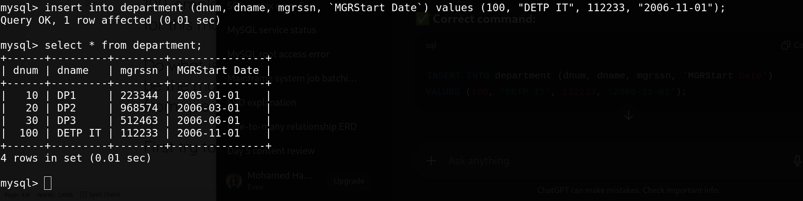

- Do what is required if you know that : Mrs.Noha Mohamed(SSN=968574) moved to be the manager of the new department (id = 100), and they give you(use your SSN from question1) her position (Dept. 20 manager)

- First try to update her record in the department table
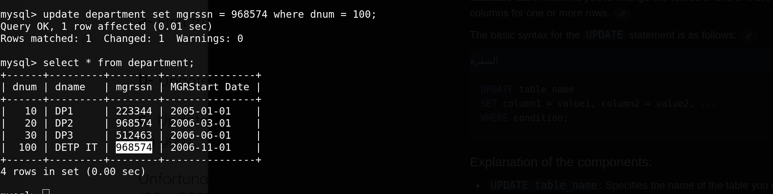

- Update the department record so you could be department 20 manager.
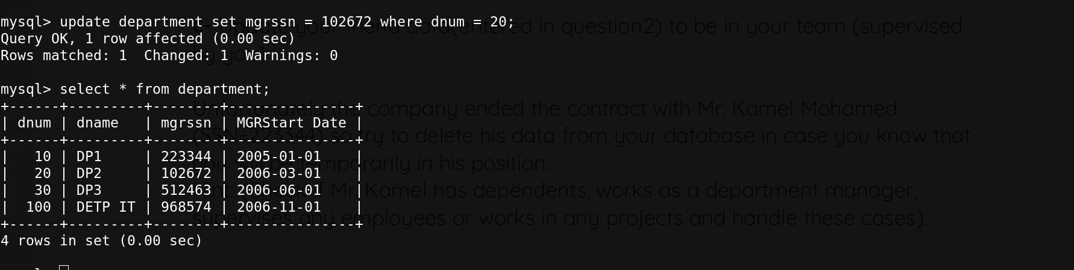
- Update your friend data(entered in question2) to be in your team (supervised by you)
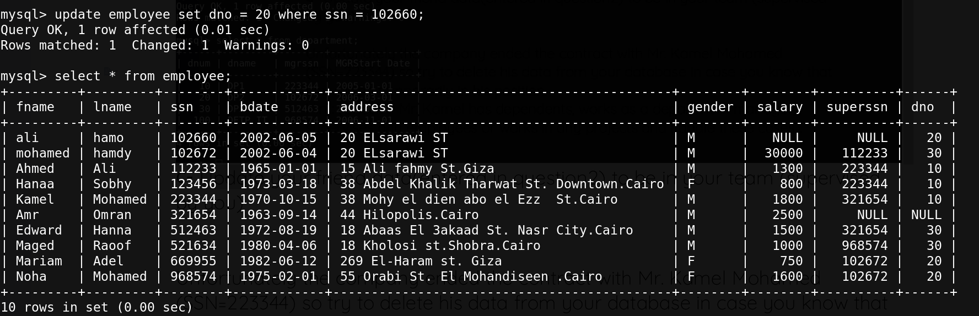

Unfortunately the company ended the contract with Mr. Kamel Mohamed (SSN=223344) so try to delete his data from your database in case you know that you will be temporarily in his position.
Hint: (Check if Mr. Kamel has dependents, works as a department manager, supervises any employees or works in any projects and handle these cases).
<UPDATED>
update works_on set essn = 10672 where essn = 223344;

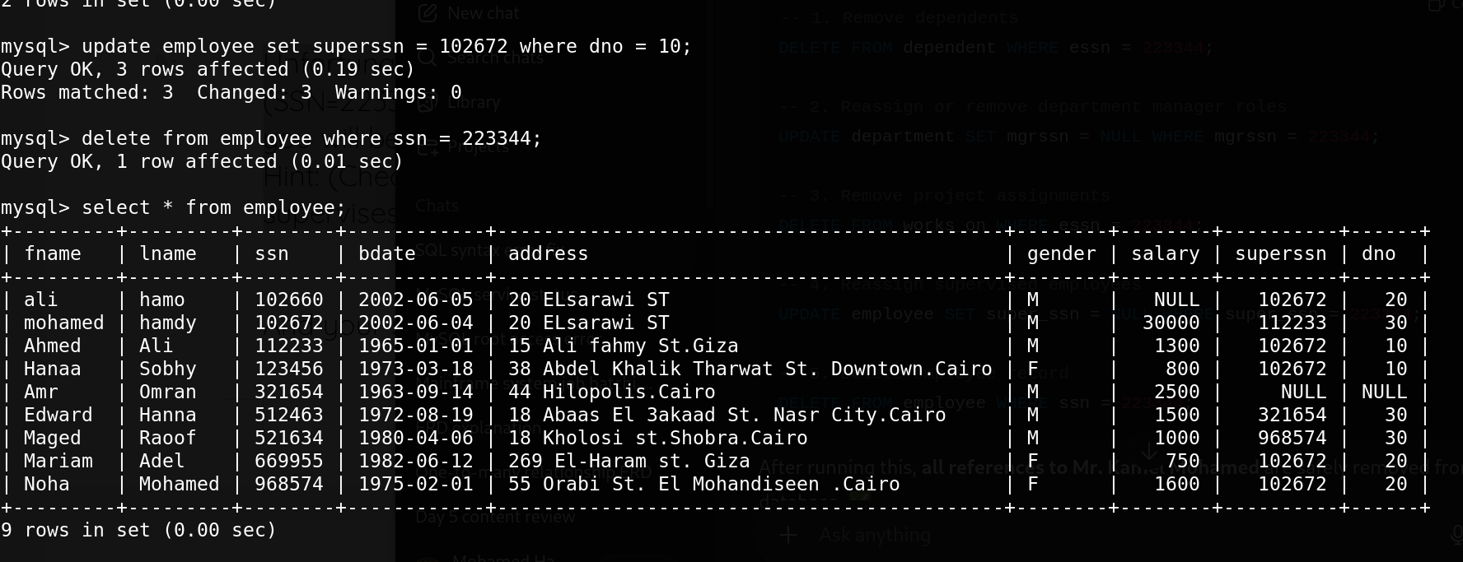
And your salary has been upgraded by 20 present of its last value.

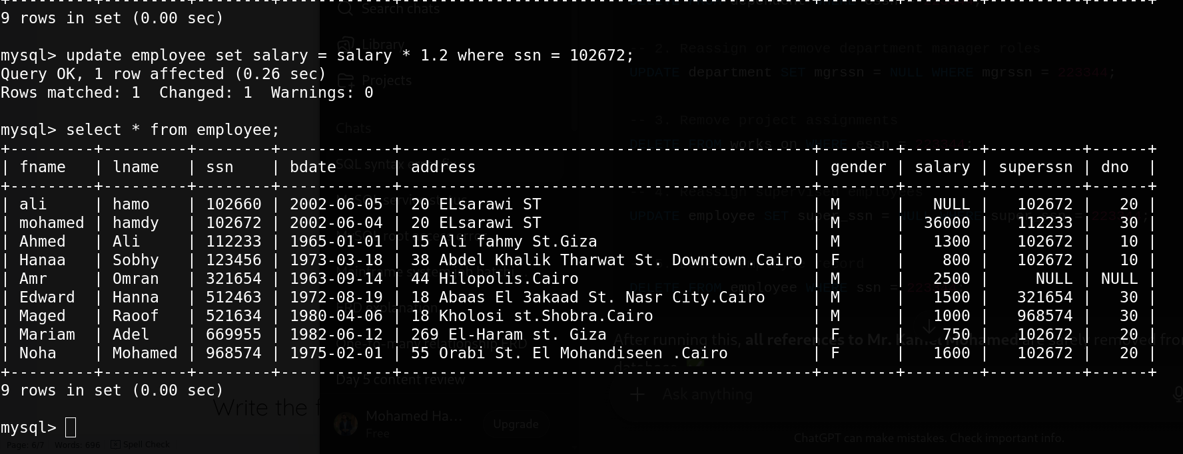

Write the following Queries:

- Display all the employees Data.
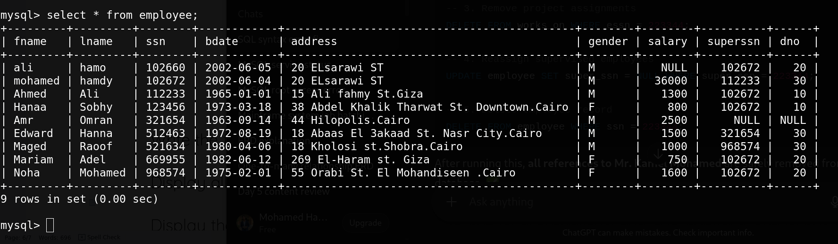

- Display the employee First name, last name, Salary and Department number.

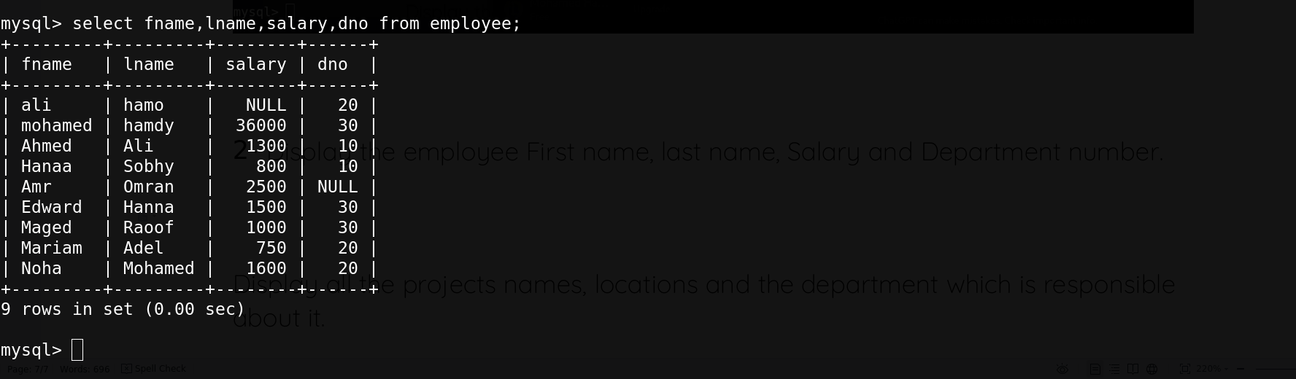

- Display all the projects names, locations and the department which is responsible about it.

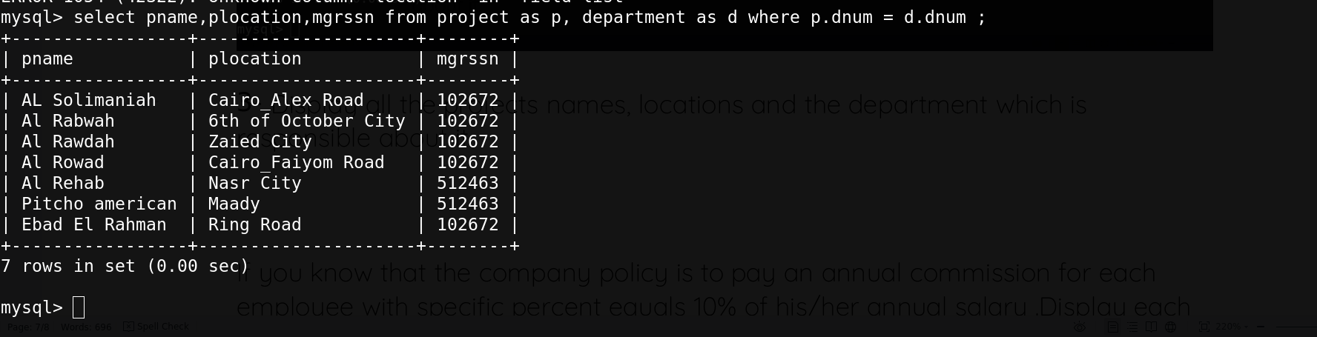

- If you know that the company policy is to pay an annual commission for each employee with specific percent equals 10% of his/her annual salary .Display each employee full name and his annual commission in an ANNUAL COMM column (alias).
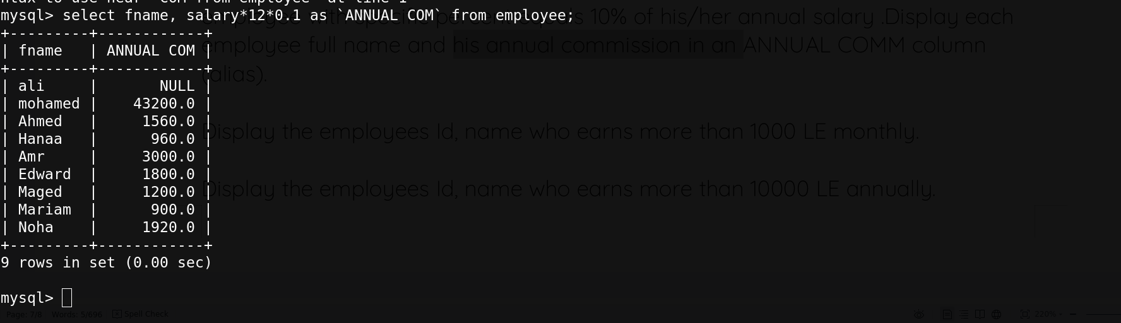
- Display the employees Id, name who earns more than 1000 LE monthly.
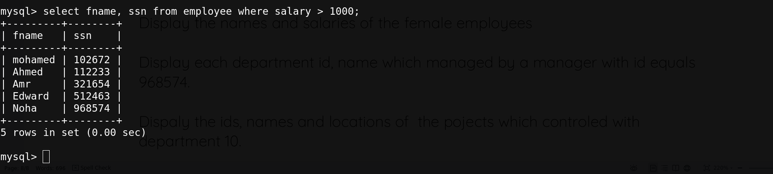
- Display the employees Id, name who earns more than 10000 LE annually.
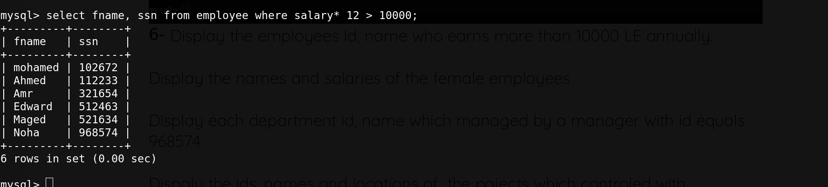
- Display the names and salaries of the female employees
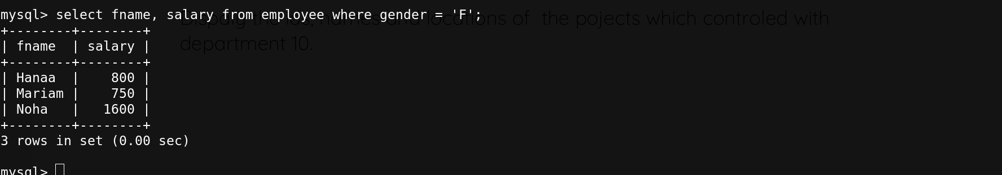
- Display each department id, name which managed by a manager with id equals 968574.
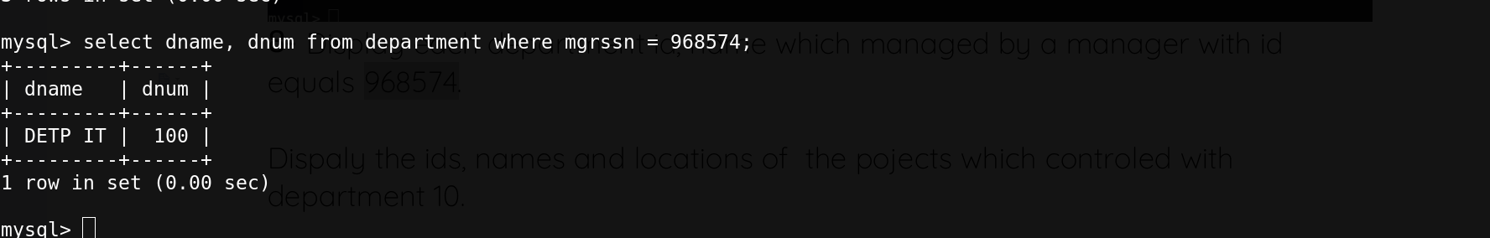

- Dispaly the ids, names and locations of the pojects which controled with department 10.
